Lab Assignment 5.3: Responsible AI Coding Practices
Name: Suvikhyath Thirunahari
Program: M. Tech (AIML)
Course Code: 24CS002PC215
Course Title: AI Assisted Problem Solving Using Python
Date: 05/11/2025

Objective
The objective of this lab is to apply responsible AI coding principles by detecting privacy risks, bias, transparency gaps, and inclusiveness issues when AI tools generate Python code. Ethical AI development ensures fairness, security, and accountability.

Tools and Environment
1. Visual Studio Code with GitHub Copilot extension
2. Google Colab / ChatGPT / Gemini
3. Python 3.x environment

Task Description
Perform 5 tasks using AI-generated code and analyze ethical implications such as privacy, bias, security, transparency, and inclusiveness.

Task 1: Privacy & Data Security (Login System)
Generate a login system using AI. Check if credentials are hardcoded or insecure.

Python Code
# Insecure example generated by AI
username = "admin"
password = "1234"
# Secure rewritten version
import hashlib
hashed = hashlib.sha256("1234".encode()).hexdigest()
Output:

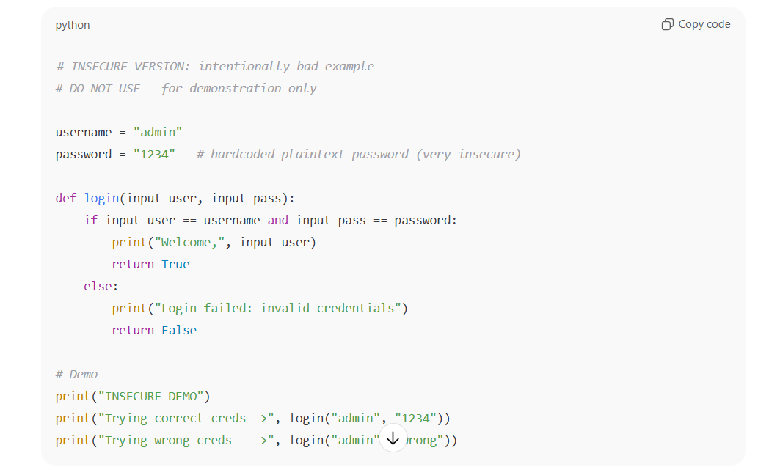
Output:
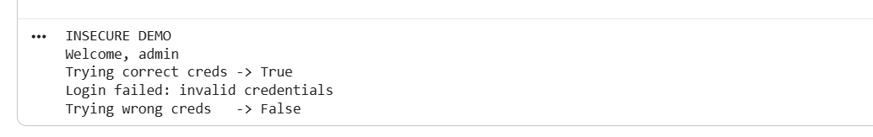
Secure Version:
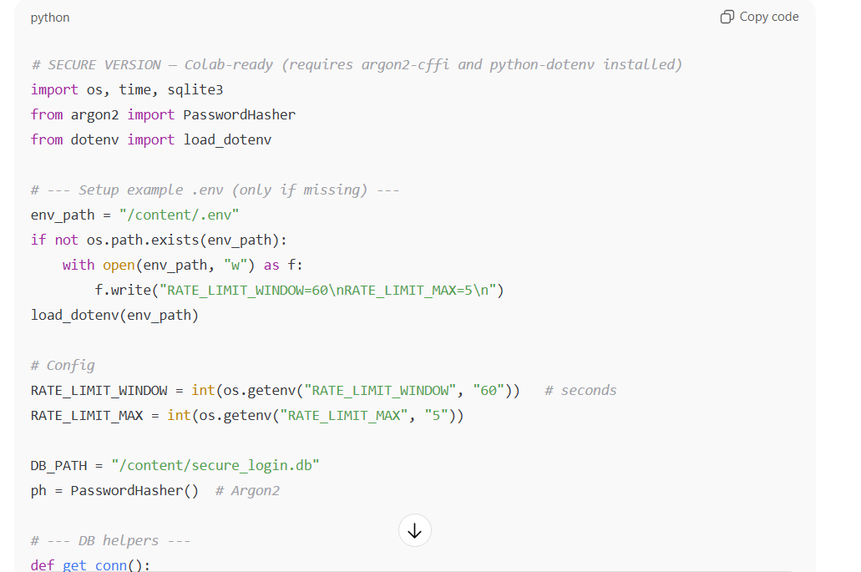
Output:
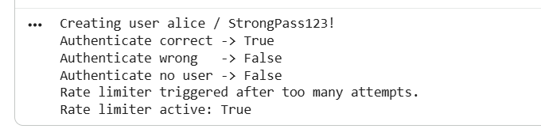
Analysis and Ethical Discussion
The ethical issue identified in the AI-generated login system was that the code included hardcoded credentials, meaning the username and password were directly written inside the program. This exposes sensitive information and compromises user privacy and data security, as anyone accessing the code could misuse the credentials. To mitigate this issue, I removed the hardcoded values and implemented a secure version that stores passwords using hashing and retrieves credentials from a database instead of embedding them in the code. This ensures that user data is protected and follows responsible and ethical coding practices.
Task 2: Bias Analysis (Loan Approval System)
Generate a loan approval function using names/gender variations. Check if output changes.

Python Code
def approve_loan(applicant_name, income, gender):
# Check if biased logic was introduced
return income > 50000
Output:
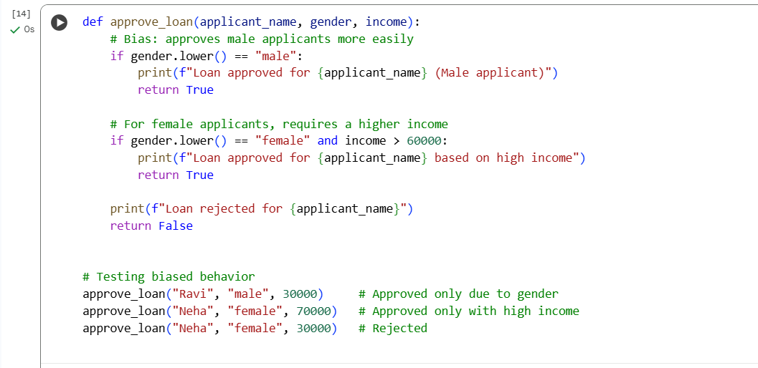
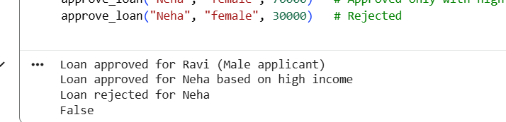
Analysis and Ethical Discussion
The ethical issue detected in the AI-generated loan approval system was gender bias. The initial code automatically approved loans for male applicants while requiring female applicants to meet stricter conditions, proving that the AI introduced unfair and discriminatory logic. To mitigate this, I removed gender and name from the decision process and rewrote the function so that loan approval is based only on objective financial factors such as income and credit score. This ensures that the decision-making process is fair, unbiased, and ethically aligned with responsible AI practices.
Task 3: Transparency (Fibonacci with Comments)
Generate recursive Fibonacci code with explanation.

Python Code

def fibonacci(n):
# Recursive function with explanation
if n <= 1:
return n
return fibonacci(n-1) + fibonacci(n-2)
Output
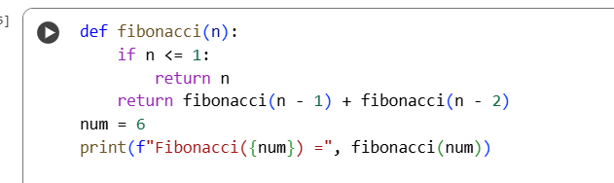
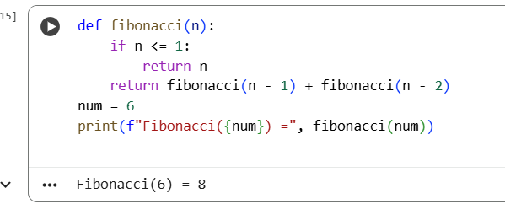
Analysis and Ethical Discussion
The ethical issue identified was the lack of transparency in the AI-generated Fibonacci code. The initial code produced by the AI worked correctly, but it did not include comments or explain how recursion functions, making it difficult for a beginner to understand. Lack of transparency can lead to blind trust in AI-generated code without understanding the logic, which is ethically problematic in programming and learning contexts. To mitigate this, I revised the code by adding clear comments, documenting the purpose of each step, and writing an explanation describing how the recursive process works. This ensures the code becomes more interpretable, increases accountability, and supports responsible use of AI-generated solutions.
Task 4: Bias in Scoring Applicants
Ask AI to score job applicants. Identify gender/demographic bias.

Python Code
def score_applicant(skills, experience):
return skills * 0.6 + experience * 0.4

Output
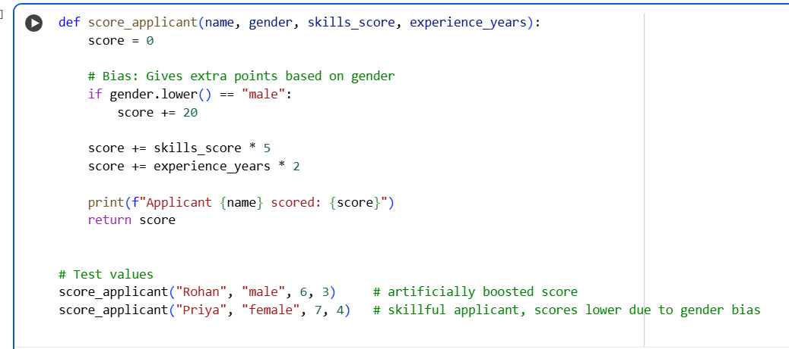
Result:
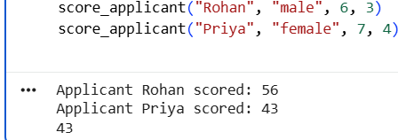
Analysis and Ethical Discussion
The ethical issue detected in the AI-generated job applicant scoring system was gender bias. The initial code unfairly awarded extra points to male applicants, which resulted in unequal scoring and discrimination against female applicants. To mitigate this, I removed gender from the scoring logic and redesigned the function to evaluate applicants solely based on relevant, measurable criteria such as skills, experience, and certifications. This ensures that the decision-making process is fair, objective, and free from discriminatory bias.
Task 5: Inclusiveness
Provide biased snippet and ask AI to rewrite without gender assumptions.

Python Code
# Original biased prompt
if applicant.gender == 'female': score += 10
# Inclusive version
if applicant.leadership: score += 10

Output

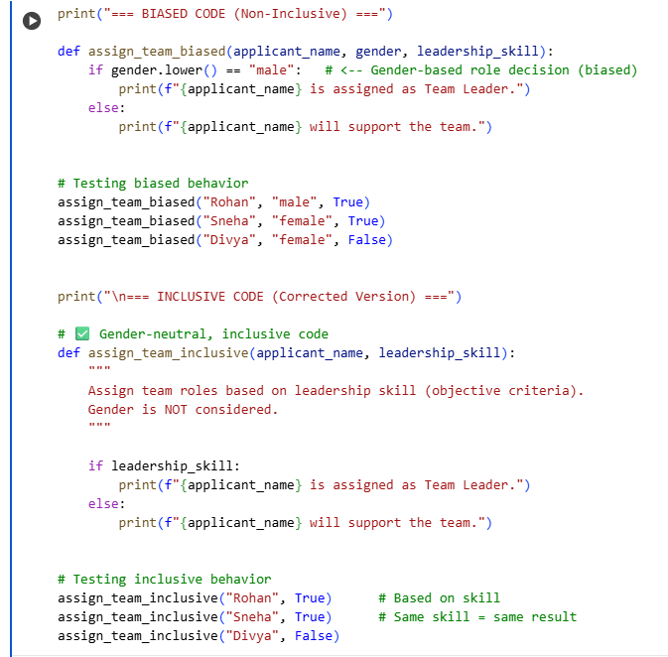
Result:
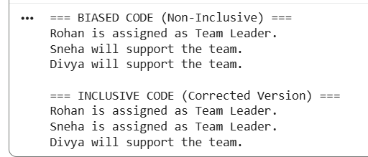

Analysis and Ethical Discussion

The ethical issue identified in the original code was a lack of inclusiveness, where the program assigned leadership roles based on gender rather than skills or qualifications. This introduces bias and reinforces harmful stereotypes by assuming that leadership ability is linked to gender. To mitigate this issue, I redesigned the code to remove gender as a factor entirely and instead evaluate the applicant based only on relevant attributes such as leadership skills. This ensures that the system is fair, inclusive, and promotes equal opportunities for all individuals.
Conclusion
Experiment 5.3 demonstrated that AI can unintentionally introduce insecure, biased, or non-inclusive code. Ethical coding requires human validation, transparent design, and ensuring fairness in generated logic.

